**ASSIGNMENTS ON DIGITAL MARKETING**

**NAME:** LINGESH WARAN G

**DEPARTMENT:** BE COMPUTER SCIENCE & ENGINEERING

**COLLEGE:** 8151 DHANALAKSHMI SRINIVASAN INSTITUTE OF

TECHNOLOGY

**NAANMUDHALVAN COURSE**: DIGITAL MARKETING

**NM ID: F374CFFF138D7499AA54D34E1EC981D2**

**ASSIGNMENT 1:**

Create a blog or website using Blogspot and WordPress. Customize

The theme design and post new article with 500 words.

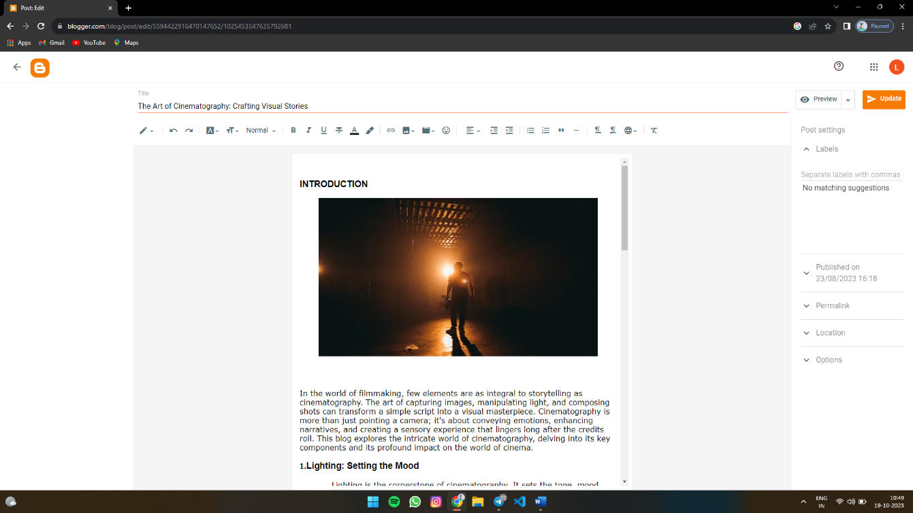 https://www.blogger.com/blog/post/edit/5594422916470147652/1025453547635792681

**ASSIGNMENT 2:**

Create a new Facebook business Page and Post one social media poster for your brand.

https://www.facebook.com/Incognitotec

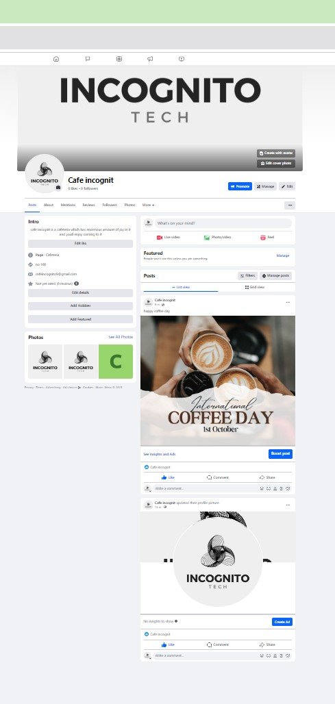

**ASSIGNMENT 3:**

Create and design a social media advertisement poster using Canva.

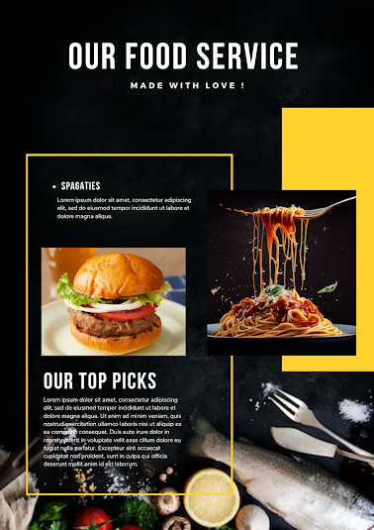

**ASSIGNMENT 4:**

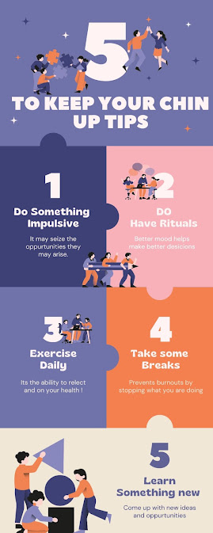4.Create email newsletter design using MailChimp or Canva tool.